OOPS basics
http://www.c-sharpcorner.com/UploadFile/tusharkantagarwal/objectorientedcsharp11162005070743AM/objectorientedcsharp.aspx

very good link
Abstraction is the ability to generalize an object as a data type that has a specific set of characteristics and is able to perform a set of actions.Object-oriented languages provide abstraction via classes. Classes define the properties and methods of an object type.

When we create a new object using the New keyword, we store a reference to that object in a variable. For instance:
Draw MyDraw = new Draw;
This code creates a new instance of Draw. We gain access to this new object via the MyDraw variable. This variable holds a reference to the object.
Early binding means that our code directly interacts with the object, by directly calling its methods. Since the compiler knows the object's data type ahead of time, it can directly compile code to invoke the methods on the object. Early binding also allows the IDE to use IntelliSense to aid our development efforts; it allows the compiler to ensure that we are referencing methods that do exist and that we are providing the proper parameter values.
Late binding means that our code interacts with an object dynamically at run-time. This provides a great deal of flexibility since our code literally doesn't care what type of object it is interacting with as long as the object supports the methods we want to call. Because the type of the object isn't known by the IDE or compiler, neither IntelliSense nor compile-time syntax checking is possible but we get unprecedented flexibility in exchange.
If we enable strict type checking by using Option Strict On at the top of our code modules, then the IDE and compiler will enforce early binding behavior. By default, Option Strict is turned off and so we have easy access to the use of late binding within our code

Public is visible to everyone. A public member can be accessed using an instance of a class, by a class's internal code, and by any descendants of a class.
Private is hidden and usable only by the class itself. No code using a class instance can access a private member directly and neither can a descendant class.
Protected members are similar to private ones in that they are accessible only by the containing class. However, protected members also may be used by a descendant class. So members that are likely to be needed by a descendant class should be marked protected.
Internal/Friend is public to the entire application but private to any outside applications. Internal is useful when you want to allow a class to be used by other applications but reserve special functionality for the application that contains the class. Internal is used by C# and Friend by VB .NET.
Protected Internal may be accessed only by a descendant class that's contained in the same application as its base class. You use protected internal in situations where you want to deny access to parts of a class functionality to any descendant classes found in other applications.

http://www.codeproject.com/Articles/330447/Understanding-Association-Aggregation-and-Composit
Association: When there is a relationship between two objects, in which both can use each other, but can exist indepently of each other
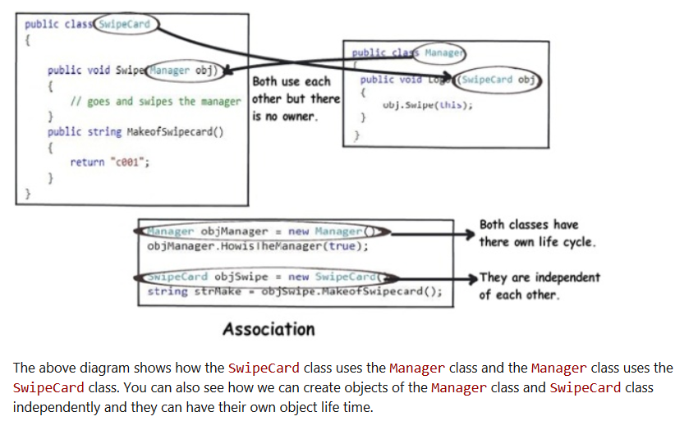

Aggregation: When two objects have a parent child relationship, but the child can still exists independently of the parent, the child object can still exists if parent object dies ( eg. In VPi project Quote is a parent class,, which aggregates different other objects which can independently exist of the Quote object)
The child object cannot belong to any other object.

Compostion:
In this relationship, both objects are heavily dependent on each other. In other words, if one goes for garbage collection the other also has to be garbage collected, or putting from a different perspective, the lifetime of the objects are the same. That’s why I have put in the heading “Death” relationship.
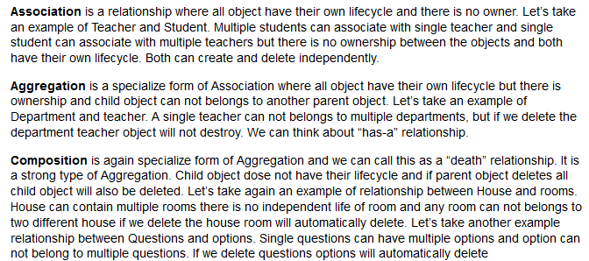

Base Class Constructor

Base class constructors can be called from derived classes. To call a base class constructor, use the base() constructor reference. This is desirable when it's necessary to initialize a base class appropriately.

When a class does not declare any constructors, the code in this example is automatically generated. The default base class constructor is called implicitly when no derived class constructors are defined. Once a derived class constructor is defined, whether or not it has parameters, a default constructor will not be automatically defined, as the preceding code showed.

If we derive a class from a base class and want to pass data from the constructor of the derived class to the constructor of the base class, it is necessary to call base constructor .
In the inheritance hierarchy, always the base class constructor is called first. In c#, the base keyword is used to access the base class constructor as shown below.
If a base class does not offer a default constructor, the derived class must make an explicit call to a base constructor by using base.
A constructor can invoke another constructor in the same object by using the this keyword. Like base, this can be used with or without parameters, and any parameters in the constructor are available as parameters to this, or as part of an expression. For example, the second constructor in the previous example can be rewritten using this:
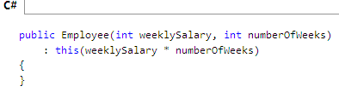
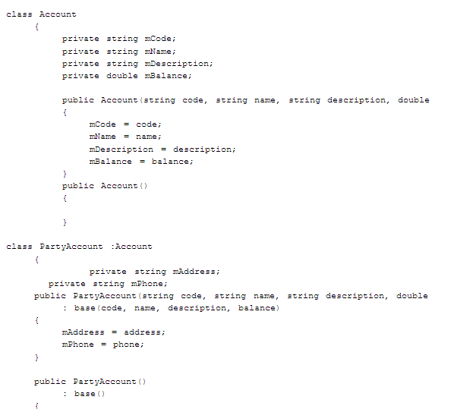
public Employee(string name, string alias)
{
this.name = name;
this.alias = alias;
}
In above example, this.name refers to private variable name in the class. If we write name = name, then this will refer to argument name of the constructor Employee and not to private variable name in the class. In this case private variable name will never be initialized.
Static classes and class members are used to create data and functions that can be accessed without creating an instance of the class. Static class members can be used to separate data and behavior that is independent of any object identity: the data and functions do not change regardless of what happens to the object. Static classes can be used when there is no data or behavior in the class that depends on object identity.

A class can be declared static, indicating that it contains only static members. It is not possible to create instances of a static class using the new keyword.

http://msdn.microsoft.com/en-us/library/79b3xss3(VS.80).aspx

When to Use Static Classes
Static members are often used to represent data or calculations that do not change in response to object state; for instance, a math library might contain static methods for calculating sine and cosine
i.e. avoid wasting resources in creating class object again and again ..use same instance of the class.
Interfaces Vs. Abstract Classes
http://www.codeproject.com/KB/cs/abstractsvsinterfaces.aspx

What is an Abstract Class?
An abstract class is a special kind of class that cannot be instantiated. So the question is why we need a class that cannot be instantiated? An abstract class is only to be sub-classed (inherited from). In other words, it only allows other classes to inherit from it but cannot be instantiated. The advantage is that it enforces certain hierarchies for all the subclasses. In simple words, it is a kind of contract that forces all the subclasses to carry on the same hierarchies or standards.
Abstract classes sit toward the top of a class hierarchy. They establish structure and meaning to code. They make frameworks easier to build. This is possible because abstract classes have information and behavior common to all derived classes in a framework.
The most famous of all abstract classes is the Object class. It may be referred to as object or Object, but it's still the same class. Object is the base class for all other classes in C#. It's also the default base class when a base class is not specified.
Overriding Summery:
A derived class may override a virtual method of the base class with the keyword override. The following restrictions must be followed.

What is an Interface?
An interface is not a class. It is an entity that is defined by the word Interface. An interface has no implementation; it only has the signature or in other words, just the definition of the methods without the body. As one of the similarities to Abstract class, it is a contract that is used to define hierarchies for all subclasses or it defines specific set of methods and their arguments. The main difference between them is that a class can implement more than one interface but can only inherit from one abstract class. Since C# doesn’t support multiple inheritance, interfaces are used to implement multiple inheritance.
The interface is defined as a set of methods (Sub and Function routines), properties (Property routines), events, and fields (variables or attributes) that are declared Public in scope.
Interface looks like a class, but has no implementation.
The only thing it contains is definitions of events, indexers, methods and/or properties. The reason interfaces only provide definitions is because they are inherited by classes and structs, which must provide an implementation for each interface member defined. So, what are interfaces good for if they don't implement functionality? They're great for putting together plug-n-play like architectures where components can be interchanged at will. Since all interchangeable components implement the same interface, they can be used without any extra programming. The interface forces each component to expose specific public members that will be used in a certain way.
For e.g. Different vehicles (e.g. boat, car, plane) have different characteristics, they all them have a common function i.e. Movement. So we have a common interface iMovemnent with function Movement, and all other classes CCar, CBoat etc implement interfaces.
All the methods of Interface are public by default and no access modifiers (like private, public) are allowed with any method of Interface.
When we create an interface, we are basically creating a set of methods without any implementation that must be overridden by the implemented classes. The advantage is that it provides a way for a class to be a part of two classes: one from inheritance hierarchy and one from the interface.
When we create an abstract class, we are creating a base class that might have one or more completed methods but at least one or more methods are left uncompleted and declared abstract. If all the methods of an abstract class are uncompleted then it is same as an interface. The purpose of an abstract class is to provide a base class definition for how a set of derived classes will work and then allow the programmers to fill the implementation in the derived classes.
Consider the concept of data hiding. Let's say you want to provide a class to some client code, but don't want to give them full access. One way to restrict access without limiting the functionality of your class is to implement an interface. Another benefit of interfaces is team development. As long as the programmers write according to the interfaces, everything will link together nicely regardless of personal choices and style.
The code in above listing contains two interfaces: IMyInterface and the interface it inherits, IParentInterface. When one interface inherits another, any implementing class or struct must implement every interface member in the entire inheritance chain.
Sealed classes are classes that can't be derived from. To prevent other classes from inheriting from a class, make it a sealed class. There are a couple good reasons to create sealed classes, including optimization and security.
Sealing a class avoids the system overhead associated with virtual methods. This allows the compiler to perform certain optimizations that are otherwise unavailable with normal classes.
Difference between Interface and Abstract Class
- Interfaces are closely related to abstract classes that have all members abstract.
- For an abstract class, at least one method of the class must be an abstract method that means it may have concrete methods.
- For an interface, all the methods must be abstract
- Class that implements an interface much provide concrete implementation of all the methods definition in an interface or else must be declare an abstract class
- In C#, multiple inheritance is possible only through implementation of multiple interfaces. Abstract class can only be derived once.
- An interface defines a contract and can only contains four entities viz methods, properties, events and indexes. An interface thus cannot contain constants, fields, operators, constructors, destructors, static constructors, or types.
- Also an interface cannot contain static members of any kind. The modifiers abstract, public, protected, internal, private, virtual, override is disallowed, as they make no sense in this context.
- Class members that implement the interface members must be publicly accessible.

Implementing Polymorphism
The key factor here is the ability to dynamically invoke methods in a class based on their type. Essentially, a program would have a group of objects, examine the type of each one, and execute the appropriate method. Here's an example:
using System;
public class WebSite
{
public string SiteName;
public string URL;
public string Description;
public WebSite()
{
}
public WebSite( string strSiteName, string strURL, string strDescription )
{
SiteName = strSiteName;
URL = strURL;
Description = strDescription;
}
public override string ToString()
{
return SiteName + ", " +URL + ", " +Description;
}
}
When we inherit above class, we have two choices to invoke constructor of the class. So this is an example of design time polymorphism. Here at design time we have to decide which method we need to invoke while inheriting the class.
Polymorphism is the capability of a program to carry out dynamic operations by implementing methods of multiple derived classes through a common base class reference. Another definition of polymorphism is the ability to treat different objects the same way. This means that the runtime type of an object determines its behavior rather than the compile-time type of its reference.

Does C# support multiple-inheritance?
No.
Who is a protected class-level variable available to?
It is available to any sub-class (a class inheriting this class).
Are private class-level variables inherited?
Yes, but they are not accessible. Although they are not visible or accessible via the class interface, they are inherited.
Describe the accessibility modifier “protected internal”.
It is available to classes that are within the same assembly and derived from the specified base class.
What’s the top .NET class that everything is derived from?
System.Object.
What does the term immutable mean?
The data value may not be changed. Note: The variable value may be changed, but the original immutable data value was discarded and a new data value was created in memory.
What’s the difference between System.String and System.Text.StringBuilder classes?
System.String is immutable. System.StringBuilder was designed with the purpose of having a mutable string where a variety of operations can be performed.
What’s the advantage of using System.Text.StringBuilder over System.String?
StringBuilder is more efficient in cases where there is a large amount of string manipulation. Strings are immutable, so each time a string is changed, a new instance in memory is created.
Can you store multiple data types in System.Array?
No.
What’s the difference between the System.Array.CopyTo() and System.Array.Clone()?
The Clone() method returns a new array (a shallow copy) object containing all the elements in the original array. The CopyTo() method copies the elements into another existing array. Both perform a shallow copy. A shallow copy means the contents (each array element) contains references to the same object as the elements in the original array. A deep copy (which neither of these methods performs) would create a new instance of each element's object, resulting in a different, yet identacle object.
How can you sort the elements of the array in descending order?
By calling Sort() and then Reverse() methods.
What’s the .NET collection class that allows an element to be accessed using a unique key?
HashTable.
What class is underneath the SortedList class?
A sorted HashTable.
Will the finally block get executed if an exception has not occurred?
Yes.
What’s the C# syntax to catch any possible exception?
A catch block that catches the exception of type System.Exception. You can also omit the parameter data type in this case and just write catch {}.
Can multiple catch blocks be executed for a single try statement?
No. Once the proper catch block processed, control is transferred to the finally block (if there are any).
Explain the three services model commonly know as a three-tier application.
Presentation (UI), Business (logic and underlying code) and Data (from storage or other sources).
Class Questions
What is the syntax to inherit from a class in C#?
Place a colon and then the name of the base class.
Example: class MyNewClass : MyBaseClass
Can you prevent your class from being inherited by another class?
Yes. The keyword “sealed” will prevent the class from being inherited.
Can you allow a class to be inherited, but prevent the method from being over-ridden?
Yes. Just leave the class public and make the method sealed.
What’s an abstract class?
A class that cannot be instantiated. An abstract class is a class that must be inherited and have the methods overridden. An abstract class is essentially a blueprint for a class without any implementation.
When do you absolutely have to declare a class as abstract?
1. When the class itself is inherited from an abstract class, but not all base abstract methods have been overridden.
2. When at least one of the methods in the class is abstract.
What is an interface class?
Interfaces, like classes, define a set of properties, methods, and events. But unlike classes, interfaces do not provide implementation. They are implemented by classes, and defined as separate entities from classes.
Why can’t you specify the accessibility modifier for methods inside the interface?
They all must be public, and are therefore public by default.
Can you inherit multiple interfaces?
Yes. .NET does support multiple interfaces.
What happens if you inherit multiple interfaces and they have conflicting method names?
It’s up to you to implement the method inside your own class, so implementation is left entirely up to you. This might cause a problem on a higher-level scale if similarly named methods from different interfaces expect different data, but as far as compiler cares you’re okay.
To Do: Investigate
What’s the difference between an interface and abstract class?
In an interface class, all methods are abstract - there is no implementation. In an abstract class some methods can be concrete. In an interface class, no accessibility modifiers are allowed. An abstract class may have accessibility modifiers.
What is the difference between a Struct and a Class?
Structs are value-type variables and are thus saved on the stack, additional overhead but faster retrieval. Another difference is that structs cannot inherit.
nccb
Method and Property Questions
- What’s the implicit name of the parameter that gets passed into the set method/property of a class?
Value. The data type of the value parameter is defined by whatever data type the property is declared as.
- What does the keyword “virtual” declare for a method or property?
The method or property can be overridden.
- How is method overriding different from method overloading?
When overriding a method, you change the behavior of the method for the derived class. Overloading a method simply involves having another method with the same name within the class.
- Can you declare an override method to be static if the original method is not static?
No. The signature of the virtual method must remain the same. (Note: Only the keyword virtual is changed to keyword override)
- What are the different ways a method can be overloaded?
Different parameter data types, different number of parameters, different order of parameters.
- If a base class has a number of overloaded constructors, and an inheriting class has a number of overloaded constructors; can you enforce a call from an inherited constructor to a specific base constructor?
Yes, just place a colon, and then keyword base (parameter list to invoke the appropriate constructor) in the overloaded constructor definition inside the inherited class.
Events and Delegates
- What’s a delegate?
A delegate object encapsulates a reference to a method.
- What’s a multicast delegate?
A delegate that has multiple handlers assigned to it. Each assigned handler (method) is called.
XML Documentation Questions
- Is XML case-sensitive?
Yes.
- What’s the difference between // comments, /* */ comments and /// comments?
Single-line comments, multi-line comments, and XML documentation comments.
- How do you generate documentation from the C# file commented properly with a command-line compiler?
Compile it with the /doc switch.
Debugging and Testing Questions
- What debugging tools come with the .NET SDK?
1. CorDBG – command-line debugger. To use CorDbg, you must compile the original C# file using the /debug switch.
2. DbgCLR – graphic debugger. Visual Studio .NET uses the DbgCLR.
- What does assert() method do?
In debug compilation, assert takes in a Boolean condition as a parameter, and shows the error dialog if the condition is false. The program proceeds without any interruption if the condition is true.
- What’s the difference between the Debug class and Trace class?
Documentation looks the same. Use Debug class for debug builds, use Trace class for both debug and release builds.
- Why are there five tracing levels in System.Diagnostics.TraceSwitcher?
The tracing dumps can be quite verbose. For applications that are constantly running you run the risk of overloading the machine and the hard drive. Five levels range from None to Verbose, allowing you to fine-tune the tracing activities.
- Where is the output of TextWriterTraceListener redirected?
To the Console or a text file depending on the parameter passed to the constructor.
- How do you debug an ASP.NET Web application?
Attach the aspnet_wp.exe process to the DbgClr debugger.
- What are three test cases you should go through in unit testing?
1. Positive test cases (correct data, correct output).
2. Negative test cases (broken or missing data, proper handling).
3. Exception test cases (exceptions are thrown and caught properly).
- Can you change the value of a variable while debugging a C# application?
Yes. If you are debugging via Visual Studio.NET, just go to Immediate window.
ADO.NET and Database Questions
What is the role of the DataReader class in ADO.NET connections?
It returns a read-only, forward-only rowset from the data source. A DataReader provides fast access when a forward-only sequential read is needed.
What are advantages and disadvantages of Microsoft-provided data provider classes in ADO.NET?
SQLServer.NET data provider is high-speed and robust, but requires SQL Server license purchased from Microsoft. OLE-DB.NET is universal for accessing other sources, like Oracle, DB2, Microsoft Access and Informix. OLE-DB.NET is a .NET layer on top of the OLE layer, so it’s not as fastest and efficient as SqlServer.NET.
What is the wildcard character in SQL?
Let’s say you want to query database with LIKE for all employees whose name starts with La. The wildcard character is %, the proper query with LIKE would involve ‘La%’.
Explain ACID rule of thumb for transactions.
A transaction must be:
1. Atomic - it is one unit of work and does not dependent on previous and following transactions.
2. Consistent - data is either committed or roll back, no “in-between” case where something has been updated and something hasn’t.
3. Isolated - no transaction sees the intermediate results of the current transaction).
4. Durable - the values persist if the data had been committed even if the system crashes right after.
What connections does Microsoft SQL Server support?
Windows Authentication (via Active Directory) and SQL Server authentication (via Microsoft SQL Server username and password).
Between Windows Authentication and SQL Server Authentication, which one is trusted and which one is untrusted?
Windows Authentication is trusted because the username and password are checked with the Active Directory, the SQL Server authentication is untrusted, since SQL Server is the only verifier participating in the transaction.
What does the Initial Catalog parameter define in the connection string?
The database name to connect to.
What does the Dispose method do with the connection object?
Deletes it from the memory.
To Do: answer better. The current answer is not entirely correct.
What is a pre-requisite for connection pooling?
Multiple processes must agree that they will share the same connection, where every parameter is the same, including the security settings. The connection string must be identical.
Assembly Questions
How is the DLL Hell problem solved in .NET?
Assembly versioning allows the application to specify not only the library it needs to run (which was available under Win32), but also the version of the assembly.
What are the ways to deploy an assembly?
An MSI installer, a CAB archive, and XCOPY command.
What is a satellite assembly?
When you write a multilingual or multi-cultural application in .NET, and want to distribute the core application separately from the localized modules, the localized assemblies that modify the core application are called satellite assemblies.
What namespaces are necessary to create a localized application?
System.Globalization and System.Resources.
What is the smallest unit of execution in .NET?
an Assembly.
When should you call the garbage collector in .NET?
As a good rule, you should not call the garbage collector. However, you could call the garbage collector when you are done using a large object (or set of objects) to force the garbage collector to dispose of those very large objects from memory. However, this is usually not a good practice.
How do you convert a value-type to a reference-type?
Use Boxing.
What happens in memory when you Box and Unbox a value-type?
Boxing converts a value-type to a reference-type, thus storing the object on the heap. Unboxing converts a reference-type to a value-type, thus storing the value on the stack.

In computer science, in the context of data storage and transmission, serialization is the process of saving an object onto a storage medium (such as a file, or a memory buffer) or to transmit it across a network connection link in binary form. The series of bytes or the format can be used to re-create an object that is identical in its internal state to the original object (actually a clone).
This process of serializing an object is also called deflating or marshalling an object. The opposite operation, extracting a data structure from a series of bytes, is deserialization (which is also called inflating or unmarshalling).

Thread safety—When the contents of a cache can be accessed from multiple threads, use some form of locking mechanism to protect one thread from interfering with the data being accessed by another thread.
Strongly Typed
Definition: A strongly typed programming languages is one that requires the type of a variable to be explicitly stated. C is a strongly typed language. You must declare the type of data a variable will store for C to interpret it:
int myVariable;
myVariable = 25;
Perl is a loosely typed language. There is no need to declare the variable type before using it:
$myVariable = 25;
$myVariable = "A String.";

The same is true with your database server, whether it is Oracle, Sybase, or Microsoft SQL Server. Database columns must be assigned a type: whether it is Text, Char, VarChar, Numeric, Int, or Binary.

Using ADO.NET, you can choose to use a generic (untyped) Data Set, or you can create a strongly-typed Data Set by creating an XSD. When you use a data set to assign values to instance members in your business objects, the data set type must match your business object member or you must convert the type from object to the type. Creating a strongly-typed dataset also ensures that a dataset does not change (in the case of a modified stored procedure) and enables intellisense rather than dictionary-based access.

By default a data set is not strongly-typed; to create a strongly-typed dataset you must first create it as a Data Set Class. Thankfully, Visual Studio .NET automates much of this task.
http://www.csharp-station.com/Articles/StronglyTypedDatasets.aspx

Delegates
Delgates are pointers to functions,
declare a delegate e.g.
Public Delegate Sub MakeDelegate (ByVal PhoneNo As String)
This Delegate class "MakeDelegate" is now capable of invoking a function, which can accept a Single String Parameter and will return VOID

Create a function with string as a parameter, if it is not a fuction with same no. and type of parameters it will generate runtime error.
Private Sub NotifyClient(ByVal PhoneNo As String)
MsgBox("This Customer is Eligible for 10% Discount")
End Sub

Now assign address to the delegate variable.
Dim objDelegate As MakeDelegate
objDelegate = AddressOf NotifyClient

Now the ObjDelegate variable, can be used as a parameter
objCustomer.ValidateCustomer(objDelegate, txtPhoneNo.Text)

‘’’ValidateCustomer function code

Public Sub ValidateCustomer (ByVal objDelegate As MakeDelegate, _
ByVal PhoneNo As String)
If PhoneNo.StartsWith ("479") Then
objDelegate.Invoke(PhoneNo)
End If
End Sub
When to Use Delegates Instead of Interfaces
Both delegates and interfaces allow a class designer to separate type declarations and implementation. A given interface can be inherited and implemented by any class or struct; a delegate can created for a method on any class, as long as the method fits the method signature for the delegate. An interface reference or a delegate can be used by an object with no knowledge of the class that implements the interface or delegate method. Given these similarities, when should a class designer use a delegate and when should they use an interface?
Use a delegate when:
- An “events” design pattern is used.
- It is desirable to encapsulate a static method.
- The caller has no need access other properties, methods, or interfaces on the object implementing the method.
- Easy composition is desired.
- A class may need more than one implementation of the method.
Use an interface when:
- There are a group of related methods that may be called.
- A class only needs one implementation of the method.
- The class using the interface will want to cast that interface to other interface or class types.
- The method being implemented is linked to the type or identity of the class: for example, comparison methods.
One good example of using a single-method interface instead of a delegate is IComparable or IComparable. IComparable declares the CompareTo method, which returns an integer specifying a less than, equal to, or greater than relationship between two objects of the same type. IComparable can be used as the basis of a sort algorithm, and while using a delegate comparison method as the basis of a sort algorithm would be valid, it is not ideal. Because the ability to compare belongs to the class, and the comparison algorithm doesn’t change at run-time, a single-method interface is ideal.

Capacity planning is the process of planning for growth and forecasting peak usage periods in order to meet system and application capacity requirements. It involves extensive performance testing to establish the application's resource utilization and transaction throughput under load. First, you measure the number of visitors the site currently receives and how much demand each user places on the server, and then you calculate the computing resources (CPU, RAM, disk space, and network bandwidth) that are necessary to support current and future usage levels. This How To describes two methodologies for capacity planning:
- Transaction cost analysis. Transaction cost analysis calculates the cost of the most important user operations of an application in terms of a limiting resource. The resource can be CPU, memory, disk, or network. You can then identify how many simultaneous users can be supported by your hardware configuration or which resource needs to be upgraded to support an increasing number of users and by how much.
- Predictive analysis. Predictive analysis forecasts the future resource utilization of your application based on past performance. To perform predictive analysis, you must have historical data available for analysis.
The ASP.Net life cycle could be divided into two groups:
1.Application Life Cycle
2.Page Life Cycle
http://www.codeproject.com/Articles/73728/ASP-NET-Application-and-Page-Life-Cycle

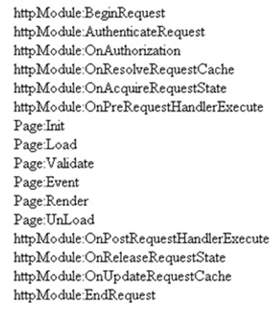
Seq Events Controls Initialized View state
Available Form data
Available What Logic can be written here?
1 Init No No No Note: You can access form data etc. by using ASP.NET request objects but not by Server controls.Creating controls dynamically, in case you have controls to be created on runtime. Any setting initialization.Master pages and them settings. In this section, we do not have access to viewstate , posted values and neither the controls are initialized.

2 Load view state Not guaranteed Yes Not guaranteed You can access view state and any synch logic where you want viewstate to be pushed to behind code variables can be done here.
3 PostBackdata Not guaranteed Yes Yes You can access form data. Any logic where you want the form data to be pushed to behind code variables can be done here.
4 Load Yes Yes Yes This is the place where you will put any logic you want to operate on the controls. Like flourishing a combobox from the database, sorting data on a grid, etc. In this event, we get access to all controls, viewstate and their posted values.
5 Validate Yes Yes Yes If your page has validators or you want to execute validation for your page, this is the right place to the same.
6 Event Yes Yes Yes If this is a post back by a button click or a dropdown change, then the relative events will be fired. Any kind of logic which is related to that event can be executed here.
7 Pre-render Yes Yes Yes If you want to make final changes to the UI objects like changing tree structure or property values, before these controls are saved in to view state.
8 Save view state Yes Yes Yes Once all changes to server controls are done, this event can be an opportunity to save control data in to view state.
9 Render Yes Yes Yes If you want to add some custom HTML to the output this is the place you can.
10 Unload Yes Yes Yes Any kind of clean up you would like to do here.

he HTML specifications technically define the difference between "GET" and "POST" so that former means that form data is to be encoded (by a browser) into a URL while the latter means that the form data is to appear within a message body. But the specifications also give the usage recommendation that the "GET" method should be used when the form processing is "idempotent", and in those cases only. As a simplification, we might say that "GET" is basically for just getting (retrieving) data whereas "POST" may involve anything, like storing or updating data, or ordering a product, or sending E-mail.
The Get method is the default.

But Specify post , If data is posted is crucial when submiting an Order (eg. On amazon.com), the browser can warn the user the data is being posted twice, if users refreshes the page.

Notes on the "get" method:

•This method appends the form-data to the URL in name/value pairs
•This method is useful for form submissions where a user want to bookmark the result
•There is a limit to how much data you can place in a URL (varies between browsers), therefore, you cannot be sure that all of the form-data will be correctly transferred
•Never use the "get" method to pass sensitive information! (password or other sensitive information will be visible in the browser's address bar)
Notes on the "post" method:
•This method sends the form-data as an HTTP post transaction
•Form submissions with the "post" method cannot be bookmarked
•The "post" method is more robust and secure than "get", and "post" does not have size limitations

------------------------------------------------------------------------------------------------------------------------------
Web Farms: Load balancer with multiple web servers is web farm.
Web Garden: If a single AppPool is configure to host multiple Worker process (on a server with multiple procesors.)
Main Advantage: The worker processes in a Web garden shares the requests that arrive for that particular application pool. If a worker process fails, another worker process can continue to process requests.

Impersonation is when ASP.NET executes code in the context of an authenticated and authorized client. By default, ASP.NET does not use impersonation and instead executes all code using the same user account as the ASP.NET process, which is typically the ASPNET account. This is contrary to the default behavior of ASP, which uses impersonation by default. In Internet Information Services (IIS) 6, the default identity is the NetworkService account.

Impersonation enables ASP.NET to execute code and access resources in the context of an authenticated and authorized user, but only on the server where ASP.NET is running. To access resources located on another computer on behalf of an impersonated user requires authentication delegation (or delegation for short). You can think of delegation as a more powerful form of impersonation, as it enables impersonation across a network.

Note Impersonation can significantly affect performance and scaling. It is generally more expensive to impersonate a client on a call than to make the call directly.

IIS implements Basic authentication, which is part of the HTTP 1.0 specification, using Windows user accounts. When using Basic authentication, the browser prompts the user for a user name and password. This information is then transmitted across HTTP where it is encoded using Base64 encoding. Although most Web servers, proxy servers, and Web browsers support Basic authentication, it is inherently insecure. Because it is easy to decode Base64 encoded data, Basic authentication is essentially sending the password as plain text.

Digest authentication addresses the primary weaknesses of basic authentication: sending passwords in plain text. Digest authentication is a challenge/response mechanism, which sends a digest (also known as a hash) instead of a password over the network. A digest is a fixed-size result obtained by applying a mathematical function (called a hash function or digest algorithm) to an arbitrary amount of data.
Cons
•Cannot delegate security credentials.
•Is only supported by Internet Explorer 5.0 and later.
•Is subject to replay attacks unless you use SSL/TLS.
•Requires storing of passwords in cleartext using reversible encryption.
Integrated V/s classic Pipeline Mode:
IIS 6.0 and previous versions allowed the development of .NET application components via the ASP.NET platform. ASP.NET integrated with IIS via an ISAPI extension, and exposed its own application and request processing model. This effectively exposed two separate server pipelines, one for native ISAPI filters and extension components, and another for managed application components. ASP.NET components would execute entirely inside the ASP.NET ISAPI extension bubble and only for requests mapped to ASP.NET in the IIS script map configuration.

IIS 7.0 and above integrates the ASP.NET runtime with the core web server, providing a unified request processing pipeline that is exposed to both native and managed components known as modules.
For eg: previouly the unmanaged resources (e.g. .htm or jpeg files etc) were not protected by “Forms Authentication Module” (i.e. if you type http://localhost/iisstart.htm, you will not be redirected to login page), but if integrated authentication is enabled even unmanaged resources would be protected. (this also implies to default error page etc).

http://rest.elkstein.org/2008/02/how-simple-is-rest.html
http://www.agile-code.com/blog/building-an-asp-net-web-api-restful-service/

What is: ASP.NET Web Api
ASP.NET Web API is the latest Microsoft framework that makes it easy to build HTTP services that reach a broad range of clients, including browsers and mobile devices. ASP.NET Web API is an ideal platform for building RESTful applications on the .NET Framework.
ASP.NET Web API is build around (or better say, into) the newest ASP.NET MVC 4 framework and for the time being is the most powerful Microsoft tool when it comes to creating RESTful services. Yes, there are other possibilities as described in the article What technology for building web services in Microsoft.Net.

WCF Data Services
WCF Data Services (formerly known as “ADO.NET Data Services”) is a component of the .NET Framework that enables you to create services that use the Open Data Protocol (OData) to expose and consume data over the Web or intranet by using the semantics of representational state transfer (REST). OData exposes data as resources that are addressable by URIs. Data is accessed and changed by using standard HTTP verbs of GET, PUT, POST, and DELETE. OData uses the entity-relationship conventions of the Entity Data Model to expose resources as sets of entities that are related by associations.
http://www.agile-code.com/blog/what-technology-for-building-web-services-in-microsoft-net/

REST stands for Representational State Transfer. (It is sometimes spelled "ReST".) It relies on a stateless, client-server, cacheable communications protocol -- and in virtually all cases, the HTTP protocol is used.
REST is an architecture style for designing networked applications. The idea is that, rather than using complex mechanisms such as CORBA, RPC or SOAP to connect between machines, simple HTTP is used to make calls between machines.
- In many ways, the World Wide Web itself, based on HTTP, can be viewed as a REST-based architecture.
RESTful applications use HTTP requests to post data (create and/or update), read data (e.g., make queries), and delete data. Thus, REST uses HTTP for all four CRUD (Create/Read/Update/Delete) operations.
REST is a lightweight alternative to mechanisms like RPC (Remote Procedure Calls) and Web Services (SOAP, WSDL, et al.). Later, we will see how much more simple REST is.
- Despite being simple, REST is fully-featured; there's basically nothing you can do in Web Services that can't be done with a RESTful architecture.

REST is not a "standard". There will never be a W3C recommendataion for REST, for example. And while there are REST programming frameworks, working with REST is so simple that you can often "roll your own" with standard library features in languages like Perl, Java, or C#.
There is no connection state; interaction is stateless (although the servers and resources can of course be stateful). Each new request should carry all the information required to complete it, and must not rely on previous interactions with the same client.
Like Web Services, REST offers no built-in security features, encryption, session management, QoS guarantees, etc. But also as with Web Services, these can be added by building on top of HTTP:
- For security, username/password tokens are often used.
- For encryption, REST can be used on top of HTTPS (secure sockets).
- ... etc.
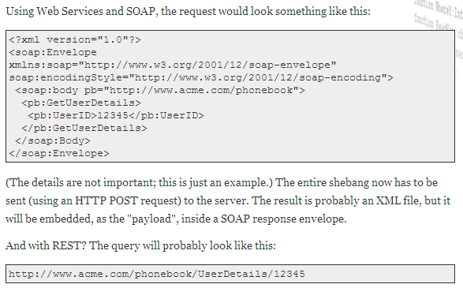
One thing that is not part of a good REST design is cookies: The "ST" in "REST" stands for "State Transfer", and indeed, in a good REST design operations are self-contained, and each request carries with it (transfers) all the information (state) that the server needs in order to complete it.
With REST, a simple network connection is all you need. You can even test the API directly, using your browser.

SOAP is mailing a letter: with SOAP, you're using an envelope; with REST, it's a postcard.

But unlike letters-vs.-postcards, REST is every bit as secure as SOAP. In particular, REST can be carried over secure sockets (using the HTTPS protocol), and content can be encrypted using any mechanism you see fit.
If you need to pass long parameters, or binary ones, you'd normally use HTTP POST requests, and include the parameters in the POST body.
As a rule, GET requests should be for read-only queries; they should not change the state of the server and its data. For creation, updating, and deleting data, use POST requests.
While REST services might use XML in their responses (as one way of organizing structured data),
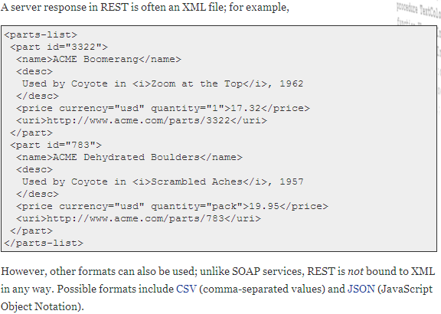
Another advantage of REST lies with performance: with better cache support, lightweight requests and responses, and easier response parsing, REST allows for nimbler clients and servers, and reduces network traffic, too.
Can be documented using WSDL or WADL. Like the rest of REST, WADL is lightweight, easier to understand and easier to write than WSDL. In some respects, it is not as flexible as WSDL (no binding to SMTP servers), but it is sufficient for any REST service and much less verbose.

Using REST in C#
Issuing HTTP GET Requests
The key classes here are HttpWebRequest and HttpWebResponse from System.Net
http://developer.yahoo.com/dotnet/howto-rest_cs.html
Caching (http://msdn.microsoft.com/en-us/library/ms978500.aspx)
- Proactive loading—When using this method, you retrieve all of the required state, usually when the application or process starts, and then you cache it for the lifetime of the application or the process.
- Reactive loading—When using this method, you retrieve data when it is requested by the application and then cache it for future requests.
Using the ASP.NET Cache
ASP.NET introduces a new key/value pair object—the Cache object. The scope of the ASP.NET cache is the application domain; therefore, you cannot access it from other application domains or processes.
Cache object provides cache-specific features, such as dependencies and expiration policies.
The Cache object is defined in the System.Web.Caching namespace. You can get a reference to the Cache object by using the Cache property of the HttpContext class in the System.Web namespace or by using the Cache property of the Page object. You can also access cached information in a user control through the Cache property of the UserControl class.
In addition to simply storing key/value pairs, the Cache object provides additional functionality specifically designed to store transient data, such as .NET Framework objects.

Using Dependencies and Expirations
When you add an item to the cache, you can define dependency relationships that can force that item to be removed from the cache under specific circumstances.

File dependency—Allows you to invalidate a specific cache item when a disk-based file or files change.
Key dependency—Invalidates a specific cache item when another cached item changes.
Time-based expiration—Invalidates a specific cached item at a predefined time.

Using Cache Callbacks
You can add a callback method to a cached item to execute when that item is removed from the cache. You can implement such a callback to ensure that the cached item is not removed from the cache or that the cache is updated based on new data.

Applying Priority to Cache Items
When the server running your ASP.NET application runs low on memory resources, items are removed from cache to free memory in a process known as scavenging. When memory is low, the cache determines which items are removed from cache based on priority. You can set the cache item priority when you add the item to the cache. Doing so controls which items scavenging removes first.
Flushing Cache
Response.Cache.SetExpires(DateTime.Now)
This code flushes the output cache, but the page does not reflect this until the original cache duration completes. For example, if you use the following directive to configure your cache, the cache resets after 10 seconds.

<%@ OutputCache Duration="10" VaryByParam="none" %>

Using an Output Cache
You can use two types of output caching to cache information that is to be transmitted to and displayed in a Web browser: page output caching and page fragment caching. Page output caching caches an entire Web page and is suitable only when the content of that page is fairly static. If parts of the page are changing, you can wrap the static sections as user controls and cache the user controls using page fragment caching.
Caching Dynamic Pages
You may find yourself designing Web pages that contain dynamic content that is dependent upon input parameters, language, or browser type.
- VaryByParam—Lets you cache different versions of the same page based on the input parameters sent through the HTTP GET/POST.
- VaryByHeader—Lets you cache different versions of the page based on the contents of the page header.
- VaryByCustom—Lets you customize the way the cache handles page variations by declaring the attribute and overriding the GetVaryByCustomString handler.
- VaryByControl—Lets you cache different versions of a user control based on the value of properties of ASP objects in the control.
You can control the location of your output cache by using the Location attribute of the @OutputCache directive. (i.e. client, server, or Client proxy).
Page fragment caching involves the caching of a fragment of the page, as opposed to the entire page.e.g. Sections on a page that contain static data.,menu controls.

ASP.NET supports a host of application performance counters that you can use to monitor the cache object activity. Monitoring these performance counters can help you locate and resolve issues in the performance of your ASP.NET cache

Using Remoting Singleton Caching
You can use .NET remoting when you need a custom cache that can be shared across processes in one or several computers. To do this, you must implement a caching service using a singleton object that serves multiple clients using .NET remoting.

You can use these unique capabilities of memory-mapped files to develop an efficient custom cache that can be shared across multiple application domains and processes within the same computer. A custom cache based on memory-mapped files includes the following components:
- Windows NT service—Creates the memory-mapped file when it is started and deletes the memory-mapped file when it is stopped.
- Cache management DLL—Implements the specific cache functionality, such as Inserting and removing items from the cache, Flushing the cache.

Using Microsoft SQL Server 2000 or MSDE for Caching
If your application requires cached data to persist across process recycles, reboots, and power failures, in-memory cache is not an option. In such cases, you can use a caching mechanism based on a persistent data store, such as SQL Server or the NTFS file system. It also makes sense to use SQL Server to cache smaller data items to gain persistency.
Because the cache service needs to access SQL Server over a network and the data is retrieved using database queries, the data access is relatively slow.
SQL Server caching can be useful when you require a persistent cache for large data items and you do not require very fast data retrieval.

Using Static Variables for Caching
Static variables are often used to save class state, and you can use them to create customized cache objects. To do so, declare your cache data store as a static variable in your custom-developed cache class, and implement interfaces to insert, remove, and access items in the data store.

Using ASP.NET Client-Side Caching and State
You can reduce the workload on your server by storing page information using client-side options. This approach has minimal security support but results in faster server performance
The main mechanisms to implement client-side caching are:
Hidden fields, View state, Hidden frames, Cookies, Query strings.

How can you cache different version of same page using ASP.NET
cache object ?
Output cache functionality is achieved by using “OutputCache” attribute on ASP.NET
page header.Below is the syntax
<%@ OutputCache Duration="20" Location="Server" VaryByParam="state"
VaryByCustom="minorversion" VaryByHeader="Accept-Language"%>
√ VaryByParam :- Caches different version depending on input parameters send
through HTTP POST/GET.
√ VaryByHeader:- Caches different version depending on the contents of the

Common caching candidates in the configuration category are:
- Location information that is required to reach remote business layer components, external services, message queuing, and so on.
- Connection data such as connection strings and file names.

State Management

1.Client Side State Management
◦View State
◦Hidden Field
◦Cookies
◦Control State

2.Server Side State Management
◦Session
◦Application Object
◦Caching
◦Database

ViewState can store the page value at the time of post back (Sending and Receiving information from Server) of your page. View State stores the value of page controls as a string (within the page) which is hashed and encoded in some hashing and encoding technology. It only contain information about page and its controls.

Disadvantages of view state?
This are the main disadvantages of using View State:

•It can be performance overhead if we are going to store larger amount of data , because it is associated with page only.
• view state is stored in a hidden field in hashed format (which I have discussed later) still it can be easily trapped.
•It does not have any support on mobile devices.

Which various modes of storing ASP.NET session ?
InProc:- In this mode Session state is stored in the memory space of the
Aspnet_wp.exe process.This is the default setting.If the IIS reboots or web
application restarts then session state is lost.
StateServer:-In this mode Session state is serialized and stored in a separate
process (Aspnet_state.exe); therefore, the state can be stored on a separate
computer(a state server).
SQL SERVER:- In this mode Session state is serialized and stored in a SQL
Server database.

Exception Handling
http://www.codeproject.com/Articles/15146/Exception-handling-in-C-and-ASP-Net

Unhandled Exceptions:
When some of exceptions are not handled in Try ? Catch ? Finally block of ASP.NET still there are ways provided by the framework facilities for handling the exception through two events:

Page_Error
Application_Error

Page and Application Error Event Handlers
This is very useful in cases where an exception is unexpected and does not occur within the bounds of a Try/Catch/Finally block. These exceptions are usually an indicator that something is substantially wrong with the application. That is, some abnormal exception has occurred and no means are provided to handle exception. In this case there is the option to deal with the error at either the Page or Application level.

If the exception is dealt at Page level, the details needs to be provided for the Page_Error event:
C# way of implementation is as follows

public void Page_Error(Object sender, EventArgs e)

{
// Implementation here
}

This event is implemented within the Page that the error may occur within.

Alternatively, the Application_Error event can be used to handled the above scenario. Unlike the Page_Error event, the Application_Error event is implemented in global.asax and any unhandled exception that occurs within our application raises from this event.

C# way of implementation is as follows

public void Application_Error(Object sender, EventArgs e)

{
// Implementation here
}

<customErrors mode="On" defaultRedirect=" errorPage.aspx"/>

Whenever an unhandled exception occurs within our application, the user is redirected to errorPage.aspx, which provides a user-friendly error message.

HttpHandlers:
Acts as a filter or intercepter between client requests and iisServer, to return customized output to the client, instead of iisserver routing the request to its default module.
http://www.himachalsoft.com/users/prashant.aspx.
Used to intercept requests like above, catch the httpContext object from the request, retrieve information from it.
And then using context.Response.Write("Welcome " & vUserName);
return customized output to client.

To create one create a class xxxhandler which implements the IhttpHandler interface (contains: public void ProcessRequest(HttpContext context) method & Isreusable property)

Why we need to create our own HTTP Handler: Sometime we need to avoid ASP.NET full page processing model, which saves lot of overheads, as ASP.NET web form model has to go through many steps such as creating web page objects, persisting view state etc. What we are interested into is to develop some low level interface that provides access to objects like Request and Response but doesn’t use the full control based web form model discussed above.
Examples:
1) Dynamic image creator – Use the System.Drawing classes to draw and size your own images.
2) RSS – Create a handler that responds with RSS-formatted XML. This would allow you to add RSS feed capabilities to your sites.
3) render a custom image,
4) perform an ad hoc database query,
5) Return some binary data.
Asynchronous handler, which implement IHttpAsyncHandler. With asynchronous handlers additional requests can be accepted, because the handler creates a new thread to process each request rather than using the worker process

Boolean IsReusable property specifies whether your handler can be pooled for reuse (to increase performance) or whether a new handler is required for each request.

Requires line in configuration file:

http://www.codeproject.com/Articles/19367/Httphandlers-ASP-NET-2-0
http://vishalnayan.wordpress.com/2011/03/10/create-your-first-http-handler-in-asp-net-3-5/ (very good one)

HTTP Modules
HttpModules are extremely powerful feature of asp.net. They act like listeners to the request that your asp.net application receives. Most of built in functionality of asp.net like output cache, session management, authentication and authorization are developed on HttpModules. An http module is a class which implements IHttpModule . This interface has two methods Init and Dispose. The Init method is where you have to write the code to implement your custom functionality. The below listing shows the list of events that are available in the Init method.
•AcquireRequestState
•AuthenticateRequestState
•AuthorizeRequestState
•BeginRequest
•EndRequest
•Disposed
•Error
•PreRequestHandlerExecute
•PostRequestHandlerExecute
•PreSendRequestContent
•PreSendRequestHeaders
You need to tell to the asp.net engine that I have a custom HttpModule. You can specify this in the web.config file under <httpModules> section. It should be written in the following format.
Eg: to implement URLRewriting in MVC

http://www.dotnetfunda.com/articles/article550-url-rewriting-with-http-module-in-aspnet.aspx

Typical uses for HTTP modules include the following:
Security Because you can examine incoming requests, an HTTP module can perform custom authentication or other security checks before the requested page, XML Web service, or handler is called. In Internet Information Services (IIS) 7.0 running in Integrated mode, you can extend forms authentication to all content types in an application.
Statistics and logging Because HTTP modules are called on every request, you can gather request statistics and log information in a centralized module, instead of in individual pages.

Custom headers or footers Because you can modify the outgoing response, you can insert content such as custom header information into every page or XML Web service response.

Reflection
Reflection is the feature in .Net, which enables us to get some information about object in runtime. That information contains data of the class. Also it can get the names of the methods that are inside the class and constructors of that object.
To write a C# .Net program which uses reflection, the program should use the namespace System.Reflection. To get type of the object, the typeof operator can be used. There is one more method GetType(). This also can be used for retrieving the type information of a class. The Operator typeof allow us to get class name of our object and GetType() method uses to get data about object?s type. This C# tutorial on reflection explains this feature with a sample class.
http://www.codersource.net/csharp_tutorial_reflection.html
Class Factory

Factory Design Pattern allows applications to provide encapsulation by hiding the complex components and their dependencies from the client. It writes an object creation code in a centralized location, called the Factory class, which helps to reduce the code redundancy in the application. The client code instantiates the Factory class and passes some parameter values to the Factory class. The Factory class instantiates the required object, based on the received Parameter values, and returns it to the client. This way, Encapsulation is preserved and also helps to build reusable components.

It exposes a number of classes to client

For eg. Consider a 3 tier application, which can have the facility to use any database (Sql Server or oracle).
- The factory is implemented as follows: a single C# interface is created with a method declared for each method that must be exposed by the database access classes.
- For each database that we want to support, we create a concrete class that implements the database specific code to perform each of the operations in the interface or "contract."
- To support the runtime determination of which concrete class to load, we create a third class which is the factory itself and reads a value from configuration file to determine which assembly to load.

http://aspalliance.com/809_Working_with_Factory_Design_Pattern_using_C
State Management
InProc: This is same as the conventional ASP session management. Session is stored in memory on the web server.
StateServer session management A second option, accomplished by setting the mode attribute to StateServer, is storing session data in a separate in-memory cache controlled by a Windows service running on a separate machine. The state service, called the ASP.NET State Service (aspnet_state.exe), is configured by the stateConnectionString attribute in the Web.config file.
Session management with SQL Server ASP.NET also allows you to store session data on a database server by changing the mode attribute to SqlServer. In this case, ASP.NET attempts to store session data on the SQL Server specified by a sqlConnectionString attribute that would contain the data source and security credentials necessary to log on to the server.

Pros and cons of the three session management solutions in brief
- InProc - stored in memory on web server
This is the default setting.
  - Pros: least overhead, fastest performance
  - Cons: breaks web clusters, restarting IIS loses sessions
- StateServer - managed by a remote service (aspnet_state)
HTTP protocol over TCP port.
  - Pros: reasonably fast, works with clusters
  - Cons: clear text, no authentication, overflows...
- SQLServer - stored in SQL Server DB tables
Uses normal ODBC connection.
  - Pros: reliable, scalable
  - Cons: relatively slow, much overhead
Client-Based State Management Options

WCF Basics
- A Service Endpoint has an Address, a Binding, and a Contract (ABC).
- An Address is a network address indicates where the service is located.
- Binding is nothing but a set of choices regarding the transport protocol (which transport protocal we have to use : http /tcp /pipe etc.) ,message encoding (tells about the message encdong / decoidng technique) ,communication pattern (whether communication is asynchronous, synchronous, message queued etc.) , reliability, security, transaction propagation, and interoperability.
- A Contract identifies what operations are available to the clients.
- In WCF, all services are exposed as contracts. Contract is a neutral way of describing the service what it does. Mainly we have four types of contracts
Service Contract:This contract describes all the available operations that client can perform on the service.
- Data Contract:This contract defines the data types that passed in and out to the service.
- Fault Contract :This contract describes about the error raised by the services.
- Message Contracts:This contract provides the direct control over the SOAP message structure. This is useful in inter operability cases and when there is an existing message format you have to comply with.
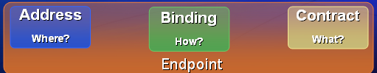

Contract defines the operations of a service
[ServiceContract]
public interface IMyContract
{
[OperationContract]
string Hello(string name);
}

Implementing the service
public class MyService : IMyContract
{
public string Hello(string name)
{
string greeting = "Hello " + name;
Console.WriteLine(greeting);
return greeting;
}
}

-------------------------------------------------------------------------------------------------------
Service Hosting
Hosting Type |  | Advantages | Limitations
IIS Hosting |  | IIS manages the life cycle of host process. ( like application pooling, recycling, idle time management, identity management, and isolation) | Only HTTP transport schemas WCF service are hosted in IIS.
WAS Hosting | WAS is a part of IIS 7.0. It comes with VISTA OS. The hosting with the Windows Activation Service is same as hosting with IIS. The only difference between these two is, IIS supports for HTTP binding only. Whereas WAS supports for all transport schemas. | - WAS supports for all available WCF transports, ports, and queues.  - WAS manages the life cycle of host process. | Some adv of self hosted processing is missing.
Self Hosting | In this technique developer is only responsible for providing and managing the life cycle of the host process. In this one host service must be running before the client calls the service. To host the service we use the .NET class ServiceHost. We have to create an instance of the "ServiceHost". Constructor of this class takes two parameters: service type, base address. (Base address can be empty set.) | - Developer can have explicit control over opening and closing the host.  - In-Proc hosting can be done. | Missing the host process life cycle management  Hosting a WCF service inside a console application is typically useful during the application's development phase. This makes them easy to debug, easy to get trace information from to find out what is happening inside of the application, and easy to move around by copying them to new locations.
WCF channels can implement sessions in a variety of different ways
One way WCF can implement a session is by the lifetime of the transport channel. Channels can also take advantage of WS-SecureConversation or WS-ReliableMessaging to represent sessions on the wire.
The lifetime of a session corresponds to the lifetime of the channel
A session begins when a client creates/uses a new session-aware channel -- it ends when the client closes it.

WCF supports Web Services Reliable Messaging (WSRM) is a specification that allows two systems to send messages between each other reliably. The aim of this is to ensure that messages are transferred properly from the sender to the receiver.

Wire Protocol
The main concept in WSRM is that of a Sequence. A sequence can be thought of as the "reliability contract" under which the RMS and RMD agree to reliably transfer messages from the sender to the receiver. Each sequence has a lifetime, which could range from being very short (I create a sequence, deliver a few messages, and terminate) to very long. In fact the default maximum number of messages in a sequence is 2^63, which is equivalent to sending 1000 messages a second for the next 292 million years!
Instancing
The instancing behavior (set by using the System.ServiceModel.ServiceBehaviorAttribute.InstanceContextMode property) controls how the InstanceContext is created in response to incoming messages.
The following instancing modes are available:
- PerCall: A new InstanceContext (and therefore service object) is created for each client request.
- PerSession: A new InstanceContext (and therefore service object) is created for each new client session and maintained for the lifetime of that session (this requires a binding that supports sessions).
- Single: A single InstanceContext (and therefore service object) handles all client requests for the lifetime of the application.

WPF
http://www.packtpub.com/article/windows-presentation-foundation-project-basics-of-working
http://dotnetslackers.com/articles/silverlight/WPFTutorial.aspx
WPF, an acronym for Windows Presentation Foundation is a subsystem of class libraries for WinFX and it enables the user to get a richer experience bringing together UI, Documents, media etc. A XAML (Extensible Application Markup Language) file which is at the heart of a WPF project can be created in several ways that includes the Notepad text editor, the Expression Blend which requires another download from Microsoft, but may not provide a easy to use XAML file to use in VS,
The fundamental power of WPF comes from the fact that it is vector based, hardware accelerated and resolution independent. The standard Windows application is alive and kicking, but you now have an additional option: the XAML Browser Application (.xbap). When you deploy this type of application to a web server, users can navigate to a URL and run your program from within the IE sandbox. The experience is similar to using a Flash application
At the same time, it’s too bad that it only works in IE. To address this issue, Microsoft is currently working on Silverlight (formerly WPF/E), a cross-platform, cross-browser subset of the .NET Framework and WPF.

XAML stands for eXtensible Application Markup Language. You can think of it as HTML for Windows applications, but it is really quite a bit more expressive and powerful. For those of you code junkies out there, XAML is really no more than a special type of CLR object serialization. It was intentionally architected to serialize CLR object graphs into an XML representation that is both verbose and human readable. The reasoning behind this was to make it possible for developers to easily edit the markup by hand and enable the creation of powerful graphical tools that could generate markup for you behind the scenes. When you compile an application that contains XAML files, the markup gets converted into BAML. BAML is a tokenized, binary representation of XAML. This binary representation is then stored inside the application’s resources and loaded as needed by WPF during the execution of your program. The main advantage of this approach is that you get a faster UI load time by reading a binary stream than through parsing XML.

Important WPF Features
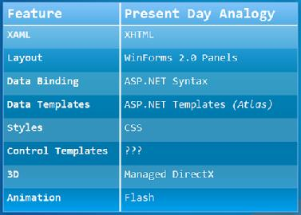

UML
http://www.exforsys.com/tutorials/uml/using-uml-with-net.html
(using uml with .net)
A use case Diagram illustrates a unit of functionality provided by the system. The main purpose of the use-case diagram is to help development teams visualize the functional requirements of a system, including the relationship of "actors" (human beings who will interact with the system) to essential processes, as well as the relationships among different use cases. To show a use case on a use-case diagram, you draw an oval in the middle of the diagram and put the name of the use case in the center of, or below, the oval.

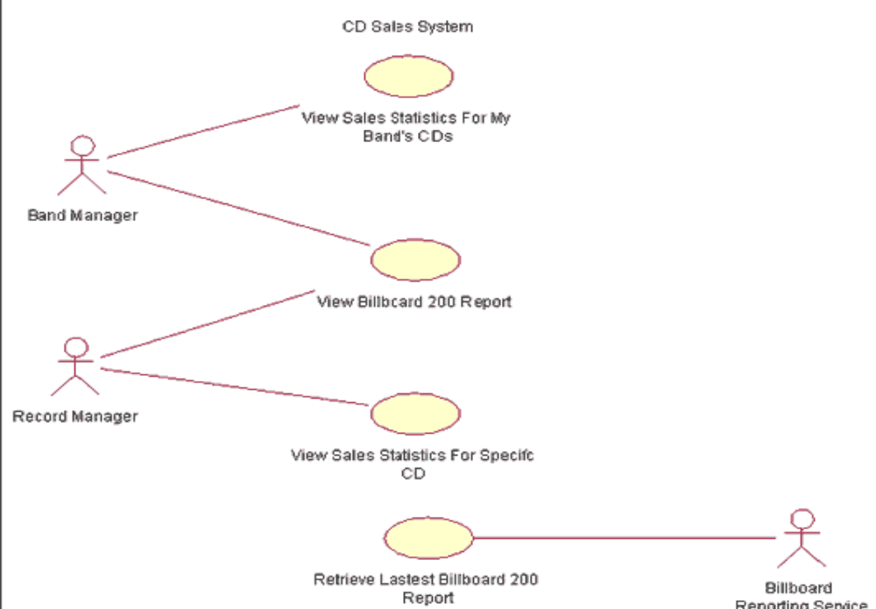
In addition, the absence of use cases in this diagram shows what the system doesn't do. For example, it does not provide a way for a band manager to listen to songs from the different albums on the Billboard 200- i.e., we see no reference to a use case called Listen to Songs from Billboard 200. This absence is not a trivial matter. With clear and simple use-case descriptions provided on such a diagram, a project sponsor can easily see if needed functionality is present or not present in the system.

Sequence diagram
Sequence diagrams show a detailed flow for a specific use case or even just part of a specific use case. They are almost self explanatory; they show the calls between the different objects in their sequence and can show, at a detailed level, different calls to different objects.

A sequence diagram has two dimensions: The vertical dimension shows the sequence of messages/calls in the time order that they occur; the horizontal dimension shows the object instances to which the messages are sent. A sequence diagram is very simple to draw. Across the top of your diagram, identify the class instances (objects) by putting each class instance inside a box (see Figure 4). In the box, put the class instance name and class name separated by a space/colon/space " : " (e.g., myReportGenerator : ReportGenerator). If a class instance sends a message to another class instance, draw a line with an open arrowhead pointing to the receiving class instance; place the name of the message/method above the line. Optionally, for important messages, you can draw a dotted line with an arrowhead pointing back to the originating class instance; label the return value above the dotted line. Personally, I always like to include the return value lines because I find the extra details make it easier to read. Reading a sequence diagram is very simple. Start at the top left corner with the "driver" class instance that starts the sequence. Then follow each
message down the diagram. Remember: Even though the example sequence diagram in Figure 4 shows a return message for each sent message, this is optional.
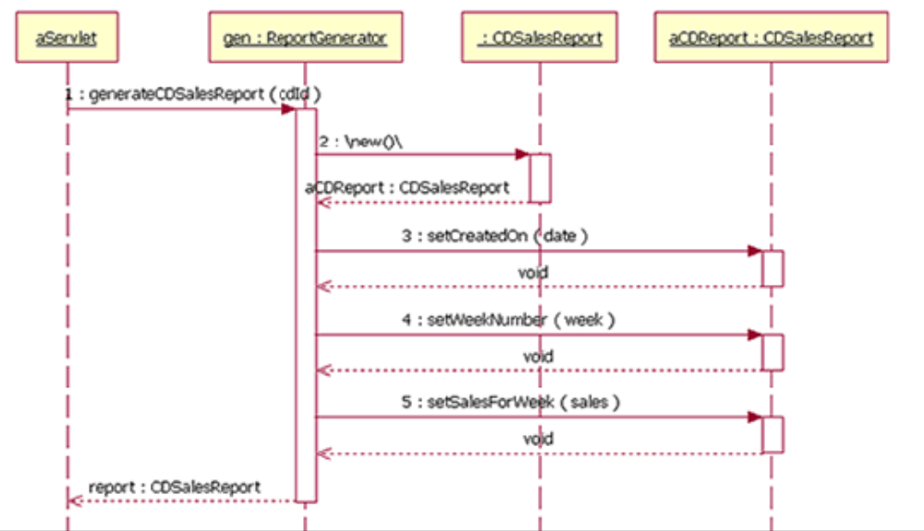

Class diagram
The class diagram shows how the different entities (people, things, and data) relate to each other; in other words, it shows the static structures of the system. A class diagram can be used to display logical classes, which are typically the kinds of things the business people in an organization talk about -- rock bands, CDs, radio play; or loans, home mortgages, car
loans, and interest rates.

you should draw the inheritance relationship1 using a line with an arrowhead at the top pointing to the super class, and the arrowhead should a completed triangle. An association relationship should be a solid line if both classes are aware of each other and a line with an open arrowhead if the association is known by only one of the classes.

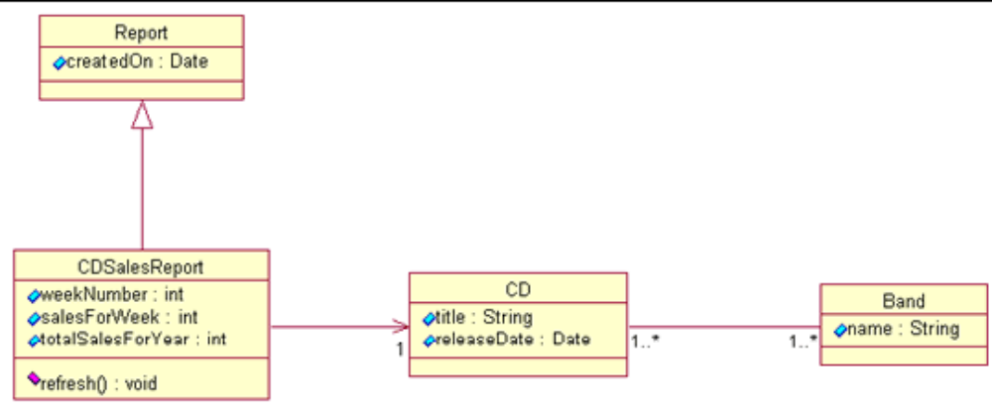
we see both the inheritance relationship and two association relationships. The CDSalesReport class inherits from the Report class. A CDSalesReport is associated with one CD, but the CD class doesn't know anything about the CDSalesReport class. The CD and the Band classes both know about each other, and both classes can be associated to one or
more of each other.

Statechart diagram
The statechart diagram models the different states that a class can be in and how that class transitions from state to state.
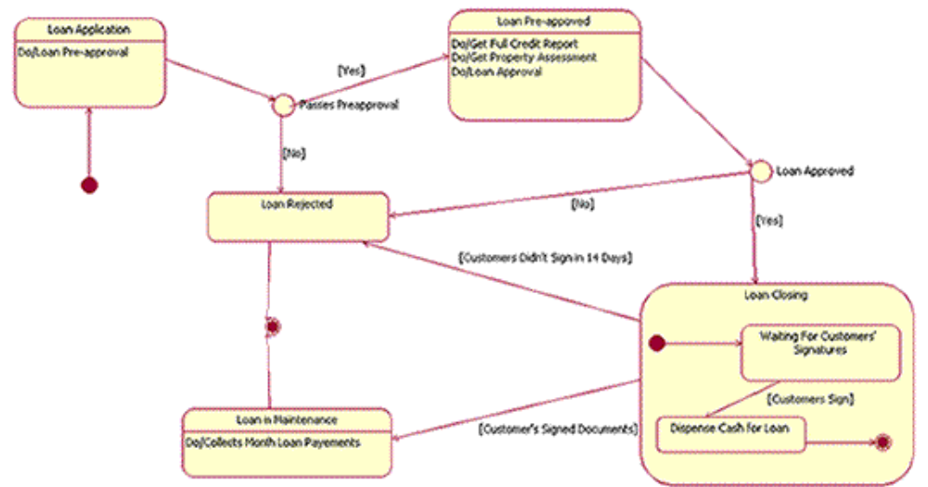
The example statechart diagram in Figure 5 shows some of the potential information they can communicate. For instance, you can tell that loan processing begins in the Loan Application state. When the pre-approval process is done, depending on the outcome, you move to either the Loan Pre-approved state or the Loan Rejected state. This decision, which is made during the transition process, is shown with a decision point – the empty circle in the transition line. By looking at the example, a person can tell that a loan cannot go from the Loan Pre-Approved state to the Loan in Maintenance state without going through the Loan Closing state. Also, by looking at our example diagram, a person can tell that all loans will end in either the Loan Rejected state or the Loan in Maintenance state.
Activity diagram
Activity diagrams show the procedural flow of control between two or more class objects while processing an activity. Activity diagrams can be used to model higher-level business process at the business unit level, or to model low-level internal class actions.
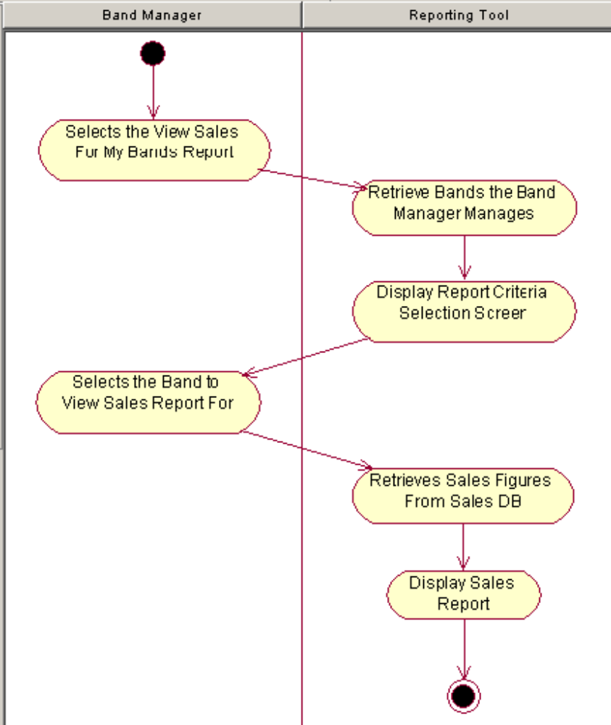
Activities that terminate the modeled process are connected to a termination point (just as in a statechart diagram). Optionally, the activities can be grouped into swimlanes, which are used to indicate the object that actually performs the activity, as shown in Figure

Component diagram
A component diagram provides a physical view of the system. Its purpose is to show the dependencies that the software has on the other software components (e.g., software libraries) in the system. shows four components: Reporting Tool, Billboard Service, Servlet 2.2 API, and JDBC API. The arrowed lines from the Reporting Tool component to the Billboard Service, Servlet 2.2 API, and JDBC API components mean that the Reporting Tool is dependent on those three components.
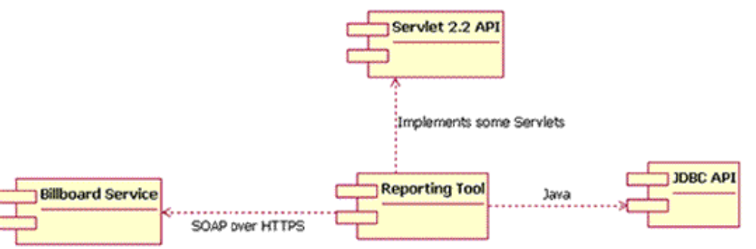

Deployment diagram
The deployment diagram shows how a system will be physically deployed in the hardware environment. Its purpose is to show where the different components of the system will physically run and how they will communicate with each other. Since the diagram models the physical runtime, a system's production staff will make considerable use of this diagram.

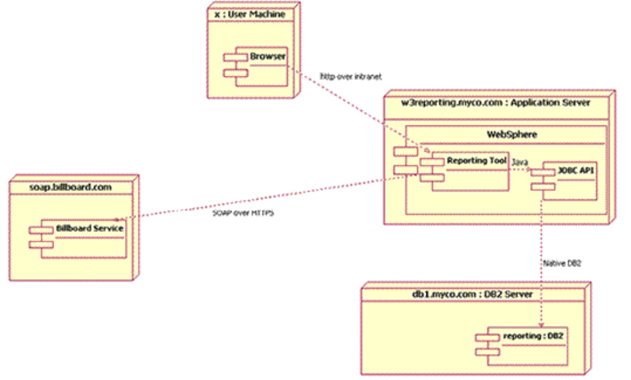
Domain Driven Design
the hart of software is its ability to solve domain related problems for its user” -- domain driven design

